
Republic of Iraq
Ministry of Higher Education and
Scientific Research
Al –Nahrain University
College of Science

Study of Thermal Properties of NiTi Thin Film Shape Memory Alloy

Athesis
Submitted to the
College of Science, Al –Nahrain University
in Partial Fulfillment of the Requirements for
the Degree of Master of Science
in Physics

By
Hadeel Thamer Khudhair
(B.Sc.2003)

Supervisor
Dr. Emad K. Al-Shakarchi

March 2008 A.D Rabea Al-Awal 1428 A.H

بسم الله الرحمن الرحيم
وفوق كل ذي علم عليم
صدق الله العظيم

يوسف /۷6

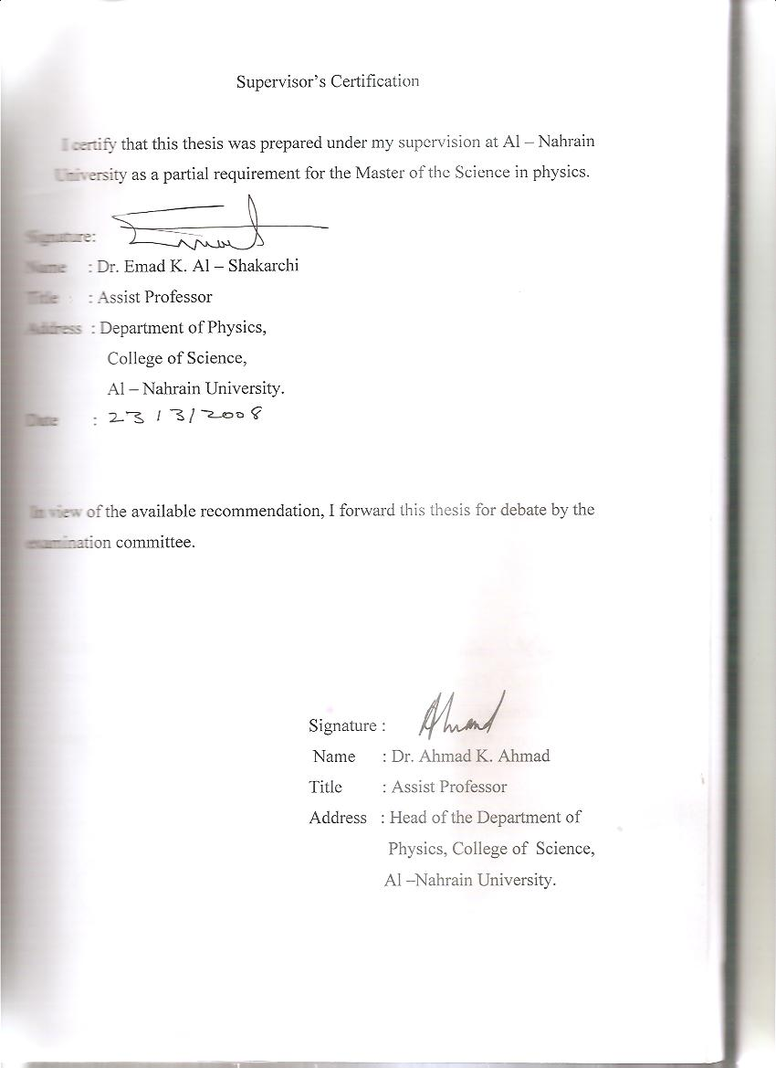
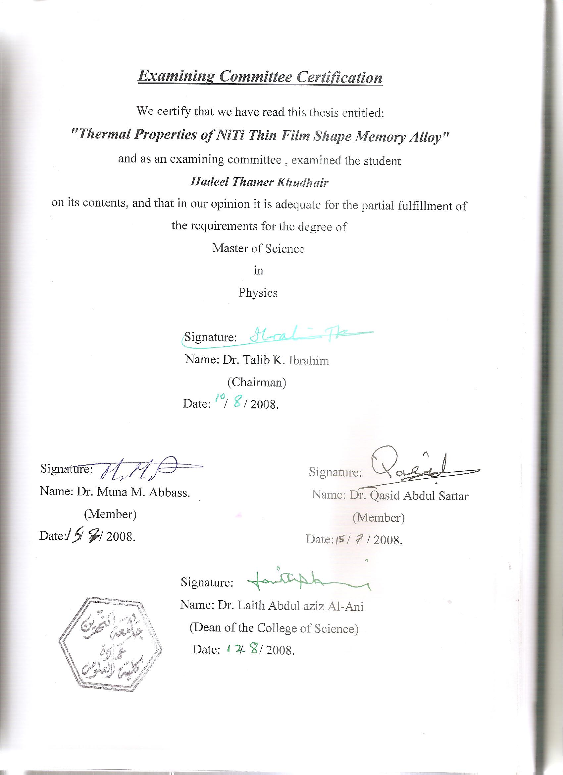

DEDICATED ….
TO MY
MOTHER

Acknowledgment
First thank God for helping me to complete this thesis. I should like to express my sincere thanks to my supervisor Dr. E. K. Al- Shakarchi for his guidance and his patience.
My thanks to the Head of physics department Dr. Ahmed Kamal and the staff of the physics department. Also my thanks to the college of science and Al- Nahrain University.
I am also grateful to my mother, sister and my husband and I would like to thank all my friends and everyone whom presented any help to finish this work.

Abstract

Shape memory alloys (SMA) or intelligent material, which are also called smart material, are a group of metallic alloys that undergo phase transformation from Austenite to Martensite when heated or subjected to appropriate stresses. After cooling or removing the stress, they have the ability to remember their previous structure and return to it.
The concern of this study is on the thermal properties of NiTi thin film and its substrate as an attempt to understand the behavior occurring in the thin film slide represented by breaking it at certain values of voltage, current and substrate temperature (Ts). We have selected NiTi alloy because of its important medical and industrial applications.
Thermal conductivity and heat capacity of NiTi thin film have been calculated theoretically and the thermal conductivity and heat capacity of glass substrate are measured experimentally. The cause of breaking in the thin film slide is the result of large difference in the thermal properties represented by thermal conductivity and heat capacity between the NiTi thin film and glass substrate. This is because the glass can not bear the high amount of heating energy resulting during the phase transformation process between Austenite and Martensite which exerts on the thin film slide.

Contents

Chapter One:
General Principles of Shape Memory Alloys
1-1 Introduction 1
1-2 Shape memory alloy 6
1-3 Mechanism of shape memory effect 7
1-4 Types of shape memory 8
1-4-1 One-Way Effect
1-4-2 Two-Way Effect
1-5 Properties of Martensitic transformation 9
1-6 Nickel-Titanium 11
1-7 Crystal structure 12
1-8 Crystal structure of solid material 13
1-9 Transformation thermodynamic 14
1-10 Transformation temperature 15
1-11 Theory of thermal properties 16
1-11-1 Specific heat
1-11-2 Thermal conductivity

1-12 Thermal phenomena in SMA behavior 21
1-13 Energy dissipation generated by phase transformation 23
1-11 Literature survey of NiTi shape memory alloys 24

Chapter Two:
Experimental and Theoretical Details
  - Introduction 33
  - Experimental part 33
2-2-1- Lees disc method
2-2-2-The spscific heat capacitymeasurement
2-3 Theoretical calculations 36

Chapter Three:
Results and Discussion
3-1 Introduction 38
3-2 Thermal conductivity measurements of glass substrate 38
3-3 Heat capacity measurement of glass substrate 40
3-4 Thermal calculation of thin films 41
3-4-1-Thermal conductivity from I-V characteristics
3-4-2-Thermal conductivity from the area under the curve

Chapter Four:
Conclusion and Future Work
4-1 Conclusion and future work 52

References

Chapter

One

Chapter one General principle of shape memory alloy

1-1 Introduction :
Shape memory alloys are a new material which are able to storage the information which used at a certain time with different ways and represented by (SMA), where the procedure that is affected on the geometrical shape of a certain materials called shape memory effect (SME).
The first observation that was recorded on the SMA was done by Change and Read in (1932) [1], since that time many researches have been worked on this type of alloy, because of the superior memory and the properties of these smart materials that they have the ability to remember their previous shape before deformation and return to principle shape after removing the stress or decreasing the temperature. Alloys exhibited this behavior called two way shape memory alloy that means it has a reversible process, while there are some alloys transform from Austenite, crystallographically more ordered parent phase to Martensite, crystallographically less ordered product phase and cannot go back to the main phase or in other words it has irreversible process and refered to one way memory effect. NiTi alloys had been consider one of the famous SMA in the present time because it has low transformation temperature in the range of (37- 45)˚C that making it applied in a different medical and industrial technology .
Really there is a hysteresis during Austenite and Martensite phase transformation yields an acceptable energy loss capacity. Furthermore, lack of residual strains following unloading , that observed in high temperature at the end of conversion of Martensite into Austenite [2], this strain depending upon the material temperature, since it is increasing and decreasing with temperature.
Chapter one General principle of shape memory alloy
NiTi alloy having non- linear hysterises which is resulted from phase transformation and also the dynamical characteristics of the alloy is
depend on such parameters as temperature and loading rates. It is well known that shape memory alloys can exhibited shape memory effect and pseudoelastic behavior, which is related to parent phase represented by
solid phase, displacive phase transformation between Austenite and Martensite [3]. During a Martensitic transformation, atoms of a highly ordered crystal rearrangement in a coordinated manner loading to a new crystalline phase. These transformations which induced by temperature occurs over a wide range of temperatures (37-50) ˚C. In the material science literatures, Martensitic transformations are often further subdivided into those which are reversible or thermoelastic for SMA and those which are irreversible for Martensitic steels.
Martensitic transformations are partitioned into two categories called proper and reconstructive Martensitic transformations [4]. Proper Martensitic transformations are identified by the Austenite and Martensite crystals having a group- subgroup symmetry relationship . This has been shown to be a necessary feature for a material to exhibit a shape memory effect, since it guarantees that Austenite is a unique configuration to which Martensite can revert [5] . Additionally, if high symmetry Austenite and low symmetry Martensite configuration are connected by an infinitesimal deformation,the phase transformation is likely to be reversible upon cooling or heating in some neighborhood of the transformation temperature [6]. In a reconstructive Martensitic transformation by contrast, no group- subgroup relationship exist between the crystal configuration. Reconstructive Martensitic transformations exist in many materials, including steel, CsCl, NaCl and other alkali –halides [7].
Chapter one General principle of shape memory alloy
The transformation SMA can be determined by exothermic and endothermic peaks from differential thermal analysis (DTA) or differential scanning caloremetry (DSC) chart that represent the mechanism of interaction and phase transformation from one phase to another. The advancing in the shape memory effect through many researches done in the world give us more details on the understanding that effect depends on the theories such as Landau theory, since this theory originated as a description of continuous phase transformations and it have a particular importance, because it is a differential form of the Gibbs free energy. The basic ingredients of a Landau model are an order parameter which encodes the atomic configurations through the transformation and the thermodynamic potential energy which is a function of this order parameter [1]. Many alloys that exhibit SMA mentioned in the table (1-1), the most significant of SMA represented by the Nickel and Titanait alloys called Nitinol (nicked titanium naval ordnance laboratory ) [8].
This particular alloy has very good electrical conduction and mechanical properties, long fatigue life and high corrosion resistance as shown in table (1-2) which represented the physical and mechanical properties of NiTi SMA [9]. When an electric current is passed directly through NiTi wire, it can generate enough heat to cause the phase transformation due to the influence of electric field applied on electrons, it will move in one direction with components of drift velocity which cause the motion of electrons under the influence of the electric field. The presence of thermal velocity which is the second component of the electrons moving randomly and hence the collision between electrons themselves and the collision with the lattice vibrations that generates

Chapter one General principle of shape memory alloy
dissipated energy which tends to increase the environment temperature causes the phase transformation. SMA are now practically being used for coupling, actuators, medical guide wires and are hopeful candidate for samrt materials, which are already exist.

Table (1-1): Some early discovered SMA . [1]

Alloy | Composition | Transformation  temperature range  deg.CMs
Ag-Cd | 44 / 49 at % Cd | -190 to -50
Au-Cd | 46.5 / 50 at % Cd | 30 to 100
Cu-Al-Ni | 14 / 14 wt% Al 3 / 4.5 | -140 to 100
Cu-Zn-X (X= Si, Sn, Al) | A few wt% of X | -150 to 200
Cu-Zn | 38.5 / 41.5 wt% Zn | -180 to -10
In-Ti | 18 / 23 at % Ti | 60 to 100
Ni-Al | 36 / 38 at % Al | -180 to 100
Ni-Ti | 49 / 51 at % Ni | -50 to 110
Fe-Pt | Approx. 25 at % Pt | Approx. -130
Mn-Cu | 5 / 35 at % Cu | -250 to 180

Chapter one General principle of shape memory alloy
Table (1-2): Indicates the physical and mechanical properties of NiTi SMA [9].
Property | Values
Melting point (˚C) | 1250
Density ( Kg / m${}^{3}$) | 6450
Electrical resistivity (Ω m 10${}^{−6}$) | 0.5 – 1.1
Thermal conductivity, RT  (W/ m K) | 10 – 18
Thermal expansion coeff.  (10${}^{−6}$/ K) | 6.6 – 10
Specific heat (J /Kg K) | 490
Transformation enthalpy (J /Kg) | 28,000
Latent heat (J /gm) | 24.2
Elastic modulus (GPa) | 95
Ultimate tensile strength (MPa) | 800 – 1000
Elongation at fracture (%) | 30 – 50
Fatigue strength N= 10${}^{6}$ (MPa) | 350
Grain size (m10${}^{−6}$) | 20 – 100
Transformation temp. range (˚C) | -110 to +110
Hysteresis (K) | 30
Max. one way memory (%) | 7
Normal two-way memory (%) | 3.2
Normal working stress (MPa) | 100 – 130
Normal number of thermal cycles | +100 000
Max. over heating temp. (˚C) | 400
Damping capacity (SDC%) | 20
Corrosion resistance | Excellent
Biological compatibility | Excelent

Chapter one General principle of shape memory alloy
1-2 Shape Memory Alloy
Metal alloys that can recover apparent permanent strain when they
are heated to their phase transformation temperature . These materials switch from Mrtensite phase to Austenite phase upon heating and then
back to Martensite upon cooling . When heated the SMA returned to the shape it was formed in , resulting in what is termed the shape memory effect [10]. A two way SMA is one that can alternate repeatedly between two different shapes , whereas one way SMA will change shape once and remained in that form [11]. Shape memory alloys have been of interest
since their discovery in the 1930′s by Olander. Shape memory alloys have desirable properties like high work output per unit volume, superelasticity , and high damping capacity that make them suitable for use in actuators .
The fact that they can be actuated by joule heating with an electric current or with heat transfer is also a plus, however their shape memory effect that makes them unique compared to other actuator materials . The shape memory effect is the thermally induced transformation between a Martensite phase at low temperature and an Austenite phase at high temperature [12], where as in the Martensite phase the material can be easily deformed in to other shapes with relatively little force. Applying the stress to the SMA reorganizes the twin orientations along the direction of the stress. Upon heating above the austenite temperature, the crystal structure converts back to its highly ordered parent phase and the original SMA structure is recovered. The using of shape memory alloys for specific applications, the materials have to be set or trained to a specific shape. The SMAs are constrained to mandrels or fixtures with the desired shape and are then heat treated for specific period of time. The time and temperature needed to train the SMA depends on the type of SMA that used. The heat treatment is applied, since at that temperature
Chapter one General principle of shape memory alloy
the material remembers to go to that particular shape. When heat treating care must be taken to make sure the SMA reaches the required temperature and is held at that temperature for enough time. If heat treatment is too high then there can be an increase in the actuation temperature and the material can have a sharper thermal response. When comparing bulk SMA with SMA thin films, it is clear that SMA thin films are preferred because of their large energy density, high frequency response and long life time at smaller dimensions. SMA thin films can be fabricated in batch, patterned with standard lithographic technique and engineered into micron- size structure .The properties of SMA thin films strongly depend on the metallurgical factors as well as deposition conditions used to fabricate them and their properties have been assumed to be the same as bulk NiTi [13].

  - Mechanism of Shape Memory Effect
The shape memory effect is phenomenon that evens though a specimen is deformed below As (start Austenite temperature). It regains its original shape by virtue of the reverse transformation upon heating to a temperature above Af (finish Austenite temperature). The origin is of course the presence of the reverse transformation upon heating. Shape memory effect occurs when specimens are deformed below Mf (finish Martensite temperature) or at temperature between Mf and Ms (start Martensite temperature) above which the Martensite becomes unstable. Depending upon the temperature regimes, the mechanisms are slightly different. While superelasticity (SE) occurs above Af, where Martensite are completely unstable in the absence of stress.
It is now clear from the above that the essential conditions for the realization of SMA and SE are the crystallographic reversibility of Martensite transformation and avoidance of slip during deformation.
Chapter one General principle of shape memory alloy
The reason why thermoelastic alloys are favored for SME and SE is due partly to the small driving force for the transformation (which is evidence by a small temperature hysteresis), which avoids the introduction of dislocations and partly to the presence of many mobile twins, thus lead to crystallographic reversibility [14] .

1-4 Types of Shape Memory
Shape memory effect is broadly categorized into one-way shape memory, superelasticity, and two-way effect. In addition to these properties there are exist of rhombohedral phase transition. All of the above are primarily due to the Martensitic phase transformation.

1-4-1 One-Way Effect
In one-way shape memory effect, also known as pseudoplasticity (PP), the material undergoes permanent deformation and then regains its undeformed shape when the SMA specimen is heated above the transition temperature (TT). The transformation temperature depends on the stress
level of the Martensite phase and hence increases in almost all SMA with corresponding increases in stress. Typically plastic strains up to 8%, or even 11%, can be recovered in one-way SME, there is however a critical stress, above which permanent damage is caused to the SME. This critical
stress is lower than the true yield stress of the SMA and defines the upper limit to which the SMA can be safely loaded without causing damage to the SME [15]. One-way SME is a one-time phenomenon and hence proper thermomechanical treatment is needed in order to obtain a complete cycle. Care however has to be taken neither to overload nor overheat the SMA specimen, which will lead to degradation in the shape
memory effect.

Chapter one General principle of shape memory alloy

1-4-2 Two-Way Effect

Two-way shape memory (TWSM) can be trained into a SMA by thermomechanical cycling. The process of training will generally result in
the alloy remembering its low and high temperature shapes. TWSME depends solely on temperature, which means that the change in temperature will cause changes in shape. The SMA will also remember it has intermediate shape in addition to the shapes it assumes at the high and
low temperatures. In one-way shape memory effect after the completion of individual cycles of deformation and heating, the alloy must be re- deformed to repeat the SME. In TWSM only temperature must be varied to affect the change in shape. The amount of strain recovery is however lower in TWSM than in one-way SME. Thermomechanical fatigue is quite necessary for the completion of the education of the SMA. It can, however, have undesirable effects like elevation of the transformation temperatures, widening of the hysteresis loop, and an increase in the levels of residual strains [15].

  - Properties of Martensitic Transformation
Steel in a high temperature Austenite phase when quenched it will generally harden and after polishing and etching the observation with a microscope will show an extremely fine structure, which was first named (Martensite) [14,16]. Martensite is a term used in physical metallurgy to describe any diffusionless transformation product, i.e. any transformation in which form start to completion of the transformation individual atomic
movement are less than one inter atomic spacing. Martensite transformation can thus occur in many types of metallic and nonmetallic
Chapter one General principle of shape memory alloy
crystals, minerals and compound [17]. Therefore, the crystals created by such transformation called (Martensitic transformation). Diffusionless Martensitic transformation have been observed in many metals, alloys and compounds other than steel. Martensitic transformation can be defined simply a lattice transformation involving shearing deformation and resulting from cooparative atomic movement.
The properties listed below follow from the definition of Martensitic transformation [14,17,18,19].
- The Martensitic phase is a substitutional or interstitial solid solution.
- The transformation is diffusionless. The concentration of solute atoms dissolved in the Martensite phase is equal to that in the parent phase.
- Reversibility of the transformation. Martensitic reactions are very reversible in the sense that an initial atomic configuration can be repeatedly obtained. The reversibility is associated with a temperature hysteresis and the reverse reaction begins at a temperature above Ms.
- Effect of applied stress. Plastic deformation is much more important in Martensitic reaction than in nucleation and growth changes. Application of plastic stresses at any temperature in the transformation range usually increase the amount of transformation and the reaction can be completed by this means.
- Orientation relation. In Martensitic changes, there is always a definite relation between the orientation of the original structure and that of the new phase. As with habit planes it is usual possible to find all crystallographically equivalent of the relation under suitable conditions.

Chapter one General principle of shape memory alloy

1-6 Nickel- Titanium
Nickel- Titanium is considered to be the best type of shape memory alloys compared to other popular polycrystalline SMA like CuZnAl and CuAlNi [11]. The basis of the NiTi system of alloy is the binary equiatomic compound of NiTi, the intermetalic compound is extraordinary because it has a moderate solubility range for excess nickel
or titanium, as well as other metallic elements. This solubility allows alloying with many of the elements to modify both the mechanical properties and the transformation properties of the system. Excess nickel in amounts up to about 1% is the most common alloying addition, excess nickel strongly depresses the transformation temperature and increase the yield strength of the Austenite.
Another element which frequently used are iron and chromium to lower the transformation temperature and copper to decrease the hysteresis and lower the deformation stress of the Martensite. The common contaminants such as oxygen and carbon play an important role in the shifting the transformation temperature and degrade the mechanical properties, it is also desirable to minimize the amount of these elements [20]. NiTi thin films have small thermal masses and large surface to volume ratio that enable them to reduce the time needed for the SMA thin films to cool down, leading to faster heat transfer .NiTi thin films are known to have superior fatigue, corrosion resistance, work / weight ratio,
biocompatibility and ductility. Avery important quality of the thin films is their large recoverable stress that approach to 500MPa with out permanent deformation [21]. Microactuaters containing the NiTi SMA thin films have large force and actuation , but have slow response times when the temperature hysteresis is large . A way to increase the response
Chapter one General principle of shape memory alloy
time is by decreasing the thickness of the film. Another advantage of NiTi thin films is that they require low voltage since their resistivity is high . Due to the martensite and austenite phase transformation , NiTi shape memory alloys have more than one value for some of their thermal and mechanical properties appeared in the following table (1-3) [22,23].

Table (1-3). Showed the properties of equiatomic NiTi SMA for different
substrates [22,23].
Substrate material | Young׳ s modulus | Coefficient of thermal linearexpansion10${}^{−6}$K${}^{−1}$
Silicon (single crystal) | 190.8 | 2.33
Gallium Arsenide (bulk) | 85.5 | 5.73
Copper (thin film) | 50 – 130 | 4 – 16
Glass | 127.4 | 16.12

Then Austenite phase typically has higher values than Martensite phase.

1-7 Crystal structure

In mineralogy and crystallography, a crystal structure is a unique arrangement of atoms in a crystal. A crystal structure is composed of a unit cell, a set of atoms arranged in a particular way; which is periodically repeated in three dimensions on a lattice. The spacing between unit cells in various directions is called its lattice parameters. The symmetry properties of the crystal are embodied in its space group. A crystal's structure and symmetry play a role in determining many of its properties, such as electronic band structure, and optical properties [24].

Chapter one General principle of shape memory alloy
The crystal structure of a material is often discussed in terms of its unit cell. The unit cell is a spatial arrangement of atoms which is tiled in three dimensional space to describe the crystal. The unit cell is given by its lattice parameters, the length of the cell edges and the angles between them, while the positions of the atoms inside the unit cell are described by the set of atomic positions (xi, yi, zi ) measured from a lattice point.
For each crystal structure there is a conventional unit cell, which is the smallest unit that has the full symmetry of the crystal. However, the conventional unit cell is not always the smallest possible choice. A primitive unit cell of a particular crystal structure is the smallest possible unit cell one can construct such that, when tiled, it completely fills space. This primitive unit cell does not, however, display all the symmetries inherent in the crystal [25].

1-8 Cryastal Structure of Solid Material

The spatial arrangement of atoms in the material plays an important role in determining the properties of material. Materials can be divided into two categories by the way atoms are arranged within a material. An amorphous solid is a material in which there is no order of positioning of atoms within the material. The atomic arrangement in any given section of an amorphous material will look different from the atomic arrangement in any other section of the material. Materials in which atoms are oriented in a high ordered structure are called crystalline. There is also a group called polycrystalline materials, in which there are crystalline subsections that are disoriented to each other.

Chapter one General principle of shape memory alloy
Crystals are categorized by their crystal structure and underlying
lattice. Each lattice point may consist one single atom however with most material,one single atom however with most material, it consists a combination of atoms or molecules. The structure of all crystals can be described in terms of a lattice, with a group of atoms attached to every lattice point [26].

1-9 Transformation Thermodynamic
In order to produce a driving force for any kind of phase transition,
the chemical free energy of the parent phase (G${}^{p}$) must be higher than that of the emberio phase (G${}^{m}$). The transformation from the Austenite to Martensite phase requires an excess in the strain energy [27]. According to the previous words if the difference between the chemical free energy of both the Austenite and Martensite phases ($Δ$G) is not greater than the non- chemical free energy, then the transformation will not begin as shown in fig. (1-1). The condition of the transformation progress is the specimen must be supercooled to the suitable low temperature ($Δ$T${}_{s}$),
Martensite starte (M${}_{s}$) below the equilibrium temperature (T${}_{0}$), where the chemical free energy of both phases are equal. In the reverse transformation, the specimen must be heated to a high temperature above (T${}_{0}$) (Austenite start temperature A${}_{s}$). This means that the forward and reveres transformation needs a driving force.

Chapter one General principle of shape memory alloy

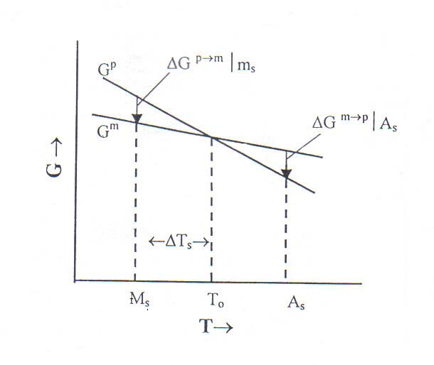

Figure (1-1).Temperature dependence of chemical free energy of the parent and
Martensite phases [1].

1-10 Transformation Temperature

One of the most important parameters to be considered when designing devices with SMA is the transformation temperature of the SMA. The transformation temperature or θ0 is the temperature where the
chemical free energy of parent phase (Austenite) and Martensite phase are equal [28]. The Austenite phase is usually above the transformation
temperature, and the martensite phase is usually below it, but these observations does not imply that these phases exist stable with each other in both cases below and above the transformation temperature. In other
Chapter one General principle of shape memory alloy
words the Austenite is stable for θ > θ0 , while the Martensite phase is stable for θ <θ0. However one often observed a metastable Austenite
below θ0 and a metastable Martensite above θ0, but the stable phases require energy minimization . Mckelvey and Ritchie [29] estimated that the value of θ0, by suggestion formula :

θ01 = (Ms + As) / 2 , θ02 = ( Ms +A${}_{f}$ ) /2 ……(1-1)

where θ01 and θ02 represent two possible values for θ0, Ms, As and A${}_{f}$ refers to start Martensite, start Austenite and finish Austenite temperatures respectively . Seelecke [30] suggested that the temperature θ0 follows from the balance of internal energy of SMA specimen.

Cp θ˚ = y ( θ- θ0 ) – ( HM${}_{+}$ - H${}_{A}$ ) X˚ M${}_{+}$ - ( H${}_{M−}$ - H${}_{A}$ ) X˚ ${}_{M−}$ ……(1-2)

Relating to the rate of temperature change (θ0) to the heat exchange with the environment of temperature θ0 . Where X˚ ${}_{M−}$, X˚ M${}_{+}$ are the rates of change of phase fractions, (H${}_{M−}$ - H${}_{A}$) is the difference in enthalpies of the M- phase and A- phase. CP and y are specific heat and heat exchange coefficients respectively.

  - Theory of Thermal Properties

In general the basic thermal properties of all matter are specific heat and thermal conductivity. The following discussion focuses on only these three basic properties:

Chapter one General principle of shape memory alloy

    - Specific Heat
When the specific heat of a solid is measured, the measurements are usually carried out at a certain pressure; thus the measured value is the
constant pressure specific heat Cp. The specific heat calculated theoretically is, however, the constant volume specific heat Cv. The difference between these two specific heats is given by equation (1-3):

Cp – Cv = ($α$${}^{2}$V${}_{0}$ T) / $χ$ ………………….(1-3)

Where ($α$) is the volume thermal expansion coefficient, (V${}_{0}$) is the molar volume, (T) the absolute temperature and ($χ$) is the compressibility, where [($χ$ = -dV / V) dP]. According to the first law of thermodynamics, if the heat energy supplied externally is (dQ), the increase in internal energy in the matter due to it is (dU), the thermal expansion is (dV), and the external pressure is P, then :

dQ = dU + PdV …………(1-4)

The constant volume specific heat is given by the changes in the internal energy due to temperature, as in equation (1-5):

CV = ($∂$U / $∂$T ) ……………(1-5)

In contrast, for the constant pressure specific heat, the amount of increase in the internal energy through work carried out outside and through thermally expansion must be added to the value calculated with equation (1-5). Thus, as is shown in equation (1-3), there is a difference between constant pressure specific heat and constant volume specific heat.
Chapter one General principle of shape memory alloy
Each atom in a solid thermally oscillates around its equilibrium point. These oscillations are called lattice vibrations. Lattice vibrations are the major part of the solid's internal energy that changes according to temperature. In solids particularly in metals, there free electrons matching
the atoms in number. Their kinetic energy makes a great contribution to the solid's internal energy, but since the electrons follow the Fermi-Dirac statistics, the internal energy changes very little in response to changes in temperature. Thus the specific heat of ordinary solids can be regarded as being due to the lattice vibration alone.
When the atoms are in harmonic oscillation around their equilibrium points, according to the law of equipartition of energy, for one degree of freedom the average kinetic energy and the average potential energy will both be (1/2 KB T). Thus if the number of atoms is (N) and the oscillation is three dimensional, the energy of the whole body will be given by equation (1-6):

U = 3 N${}_{A}$ KB T …………..(1-6)

Therefore if Avogadro's number is denoted by NA, the constant volume specific heat is found with equation (1-7):

Cv = ($∂$U / $∂$T ) = 3 N${}_{A}$ K${}_{B}$ 24.9 ( J / deg . mol) …………(1-7)

That is called Dulong – Petit's law. In the region of room temperature, the specific heat of monatomic solids does indeed have this value. When the temperature drops, however, the specific heat declines; near absolute zero the specific heats of all solids are known to vary as the cube of the absolute temperature [31].

Chapter one General principle of shape memory alloy

    - Thermal Conductivity
The amount of thermal conduction within a solid depends on the number of carriers which carry the heat energy and the degree of resistance to their movement within the solid. In solids the most important carriers are lattice vibrations (phonons) and the motion of electrons. Excluding metals and metallic alloys, however, in electrical insulators and most semiconductors, the contribution of electrons to the
conduction of heat is small. Lattice vibrations become waves and transmit the heat. The energy of lattice vibrations can take on only discrete values. Thus, when those become waves and are transmitted, the wave with wave number vector (q) is excited and quieted in energy quantum units [hw(q)]. That is when the lattice vibration waves collide with each other and when lattice vibrations and electrons reciprocally exchange energy, the energy is in [hw(q)] quantum units. The quanta of lattice vibration waves are called phonons. These are quite similar to photons, which are quantized electromagnetic waves.
Thus the carriers of thermal conduction in insulators and semiconductors are phonons. Consider the behavior of phonons in a solid at a certain temperature. Phonons are constantly being born and disappearing, but their average number is fixed. The wave number (q) are given by:

n${}_{q}$ = 1 / exp [( hw(q) / K${}_{B}$T) – 1] …………(1-8)

If no temperature gradient exist in the test material, this amount will be the same throughout the crystal, and no flow of heat will occur. If, however, there is a temperature gradient in the test material, there will be

Chapter one General principle of shape memory alloy
a difference in the energy distribution in the phonons according to their location within the crystal. To equalize this difference, the phonons will
spread from a location of high density to one of low density. This phenomenon is the mechanism of thermal conductivity. While spreading, phonons will collide with other phonons, be scattered by impurities and lattice defects and will move with a repeated zigzag motion. The average distance from one collision to the next is the mean free path, ($ℓ$). Using that variable, the average velocity of the phonons, ν, and the specific heat (C) for a unit volume yields the thermal conductivity given by equation
(1-9):

K = (1/3) Cv $ℓ$ ……………..(1-9)

This equation is derived for the thermal conductivity of a gaseous molecule, but phonons can be regarded as collections of particles, just as collections of molecules, so that equation (1-9) can be applied as is [31].

Chapter one General principle of shape memory alloy
1-12 Thermal Phenomena in SMA Behavior
The first principle of thermodynamics written in a variation form is
adopted as a starting point, conservation of the internal energy in an elementary reference volume:

∫ ρ de dΩ = ∫ (σ : d$∈$) dΩ + Q .......……(1-10)

where (ρ) is the material density, (de) is the elementary variation of the
specific internal energy, ($∈$) and (σ) are respectively strain and stress tensors. In case of SMA, the characteristic size of a representative microscopic volume (Ω ) corresponds to the average size of the Martensite plates (~610${}^{−3}$). It is supposed that within this representative volume, all internal parameters can be homogenized. The first term in the right hand of last equation describes the mechanical energy corresponding to the internal stress state,while the second term represents
a heat received or evolved by the material because of internal (r) and external (q) thermal sources.

Q = ∫ r dΩ + ∫ (q. n) dΓ …….… (1-11)

According to the second principle of thermodynamics, the energy relative to entropy variations within any characteristic volume is always
superior or equal to the amount of heat received by this volume :

∫ ρ ds dΩ ≥ ∫ (r ∕ T) dΩ + ∫ (q . n) ∕ dΓ ………(1-12)

where (ds) is the specific entropy variation. By using the divergence
theorem to the second term in the right hand of the equation (1-12) we
obtain the following inequality :

Chapter one General principle of shape memory alloy
∫ [ ρ ds – r ∕ T + $∇$q ∕ T ] dΩ ≥ 0 ……..…(1-13)

where T, r, q and s denotes respectively temperature , intensity of the internal heat sources , external heat flow and specific entropy. Then we introduce the specific free energy Ψ=e-ST, since (e) is the specific internal energy, (S) is the specific entropy, (T) temperature. Using equation (1-10) and (1-11), the inequality (1-13) takes the final form ,
named inequality of Clausius –Duhem :

ε2
∫ σ ∕ dε – ρ [dΨ + s dT ]- [q. $∇$T ] ∕ T ≥ 0 ….(1-14)
ε1

This inequality means that the total dissipated energy within an elementary volume should always be non –negative at each moment of
time and everywhere in the material .The first term in equation (1-14) denotes to the internal mechanical energy accumulated during transition from the state ($∈$1) to the state ($∈$2) as in fig. (1-2) [32].

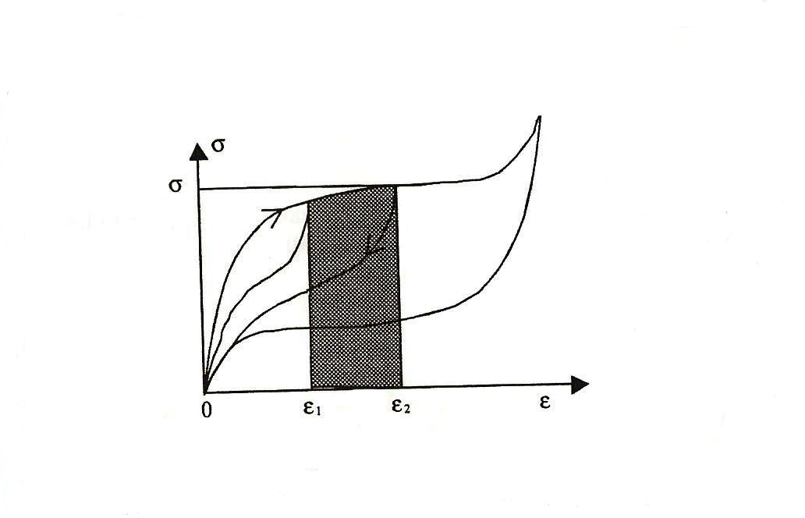

Fig.(1-2): The internal mechanical energy between states 1 and $∈$2

Chapter one General principle of shape memory alloy
1-13 Energy Dissipation Generated by Phase Transformation
When only energy generated by phase transformation is taken into
account, the following phenomena can be neglected:
- Inelastic strain contribution.
- Thermomechanical coupling.
- Thermal conductivity variations.
Then the heat transfer equation can be represented as follows:

$∇$[ K . $∇$ T ] = ρ С dT + ρ Π${}^{f}$ df - T [ρ C(T) (∂Π${}^{f}$ ∕ ∂t) df] …..…(1-15)

In this case Clausius –Duhem inequality takes a simplified form, i.e, it contains only a term corresponding to the dissipated energy generated by phase transformation.

Π${}^{f}$( f , T ). df ≥ 0 …………………..(1-16)

This inequality should be verified for all df, which means that Π${}^{f}$(f,T) = 0 . Consequently by assuming that the specific heat is constant

C = C$∈$ = T [ ∂s ∕ ∂T ] $∈$ ……………..(1-17)

The second term in Clausius – Duhem inequality containing df vanishes, then the equation of heat transfer as follows:

K ∆T = ρ C$∈$ dT - T ( ∂Π${}^{f}$ ∕ ∂ t ) df – r …..……..…..(1-18)

The second term in the right part of this equation represents the latent
heat of phase transformation. It can be also written in terms of specific
heat variations:

T ( ∂Π${}^{f}$∕ ∂T ) df = ρ C(T) dT ………………(1-19)

Chapter one General principle of shape memory alloy
The last expression seems to be advantageous because it allows to replace the use of the Martensite content an internal variable by experimental results obtained from differential scanning calorimetry testing (DSC). Finally, equation (1-18) may be rewritten in the following simplified way [32]:

K ∆T = ρ [ C$∈$ - C(T) ] …..…..…….(1-20)

1-14 Literature Survey of NiTi Shape Memory Alloys
Depending on the importance of this subject in the practical field especially in the medical and industrial applications it becomes necessary
to cover the developments on the NiTi SMA and Martensitic transformation, on which SME is based, is concisely revewed :

Hashemi and Khadem [2] studlied the behavior of NiTi suporelastic alloy and analyzed the dynamical behavior of simply supported and clamped– free beams. The observation of the system response or different conditions showed the following results:
1) Temperature increase cause an increment in stresses of start and
finish of transformation as well as a decrease in hysteresis level .
2) The superelastic leads to diminished response amplitude up to
approaching the elastic limit.
3) Increasing of stress plateaus presents a higher rate of decreasing in
response amplitude.
4) The decreasing the response of the system tends to increasing of
loading amplitude of that system.
5) The presence of different elastic modules at Austenite and Martensite
phases causes a change in system stiffness and consequently
variation in natural frequencies, which leads to an escape from
Chapter one General principle of shape memory alloy
resonance condition.
6) Under superelastic conditions, no residual stresses at the end of
loading are observed.

Landau [33] developed a phenomenological theory of phase transitions including Martensitic transformation . This theory had been
successfully modeled the properties of known phase transitions through
the concept of free energy of the crystal is expanded as a polynomial function with temperature dependent coefficient of an order parameter
that measures the extent of transformation . The form of free energy is constrained to satisfy a certain symmetry relations for the crystal of interest .Phase transformation is assumed to occur at the temperature where the free energy of Austenitie phase becomes equal to the free energy of the Martensite phase .

Shao et all [34] presented study at the molecular scale. They have applied molecular dynamics (MD) methods to the atomistic study of SMA providing valuable insight into the elastic properties of SMA, the dynamic behavior of atoms in the crystal and the mechanisms leading to initiate and a propagate of phase transformation.

Kaack et al [35] showed that the dislocation are induced in polycrystalline NiTi SMA by thermal and mechanical cycling and measured the variation of the ultrasonic velocity and the attenuation with frequency in the range of (2-60) MHz at room temperature, the frequency dependent experimental data are well described in the frame of a vibrating string model. The fits yield length and density of the dislocation

Chapter one General principle of shape memory alloy
in cycled and non-cycled samples. Depositing the sample at (300)K for a
couple of days leads to reduction the dislocation density a compained with an increase of the transition temperature.

Nasser and Guo [36] performed a series of both quasi- static and dynamic uniaxial compression tests on cylindrical samples to characterize the thermomechanical response, especially the superelastic behavior of NiTi -SMA at various temperature and strain rates. They examined that the influence of the annealing temperature on the fatigue response, they concluded that:
1) The transformation stress and the dissipated energy of NiTi - SMA
depend on the annealing temperature.
2) The dissipated energy over cycle loading tends to a minimum stable
value of about (7.8 J ⁄ m${}^{−3}$ ) as appeared in fig.(1-3) and cyclic loading
leads to a stable superelastic behavior of the alloy.
3) Repeated dynamic tests of the alloy produce smaller changes in the
shape of superelastic loop and in the dissipated enerqy than the quasi –
static cyclic tests.
4) The superelastic behavior of this material has stronger sensitivity to
temperature than the strain rate, at very high loading rates, NiTi SMA
shows properties similar to ordinary steel.

Chapter one General principle of shape memory alloy

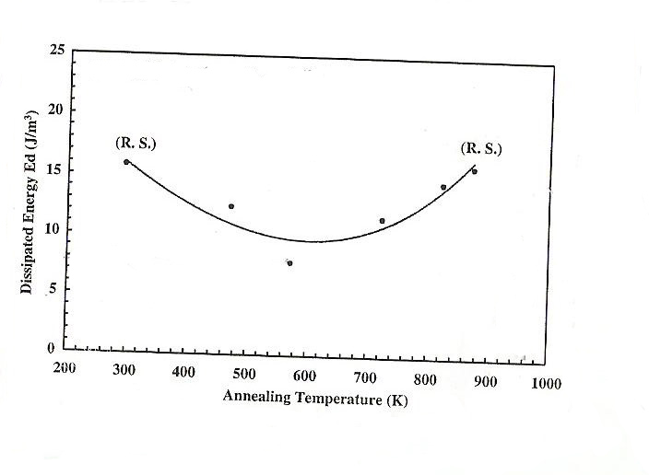

Fig.(1-3): Dissipated energy as a function of annealing temperature [38].

Huang [37] investigated the angle between the transformation front and the applied stress of some typical SMA analytically and numerically. He found that the angle (θ) against the applied stress varies from material to material depends on the transformation strain of a particular SMA, by suggesting that (θ =45˚) may be used as a parameter to classify plane stress problem, if (θ > 45˚) there is no slip line, if (θ =45˚) there is one slip line, if (θ < 45˚) there are two slip lines.

Wan et al [38] they calculated the driving force of premartensitic transformation (PT) based on the electron transverse acoustic (TA) phonon interaction Hamiltonian. The driving force of Ni2MnGa alloy is about 172.2Mev, larger than that of NiTi-Fe (52.2Mev) or Ni-Al alloy (17Mev). They investigated that the nucleation rate of premartensitic transformation in the interaction system by considering the electron
Chapter one General principle of shape memory alloy
phonon interaction and the condensation of transverse acoustic phonon. The following double sine- Gordon equation of atomic phase angle proposed to study the nonlinear characteristics of premartensitic transformation as :

θι = 4 arctan [λ . exp(ι-γ)] + 4 arctan [λ . exp(ι+γ) ] ………..(1-21)

Where λ and γ are parameters, θι atomic phase angle, ι denotes of the
number of atoms.

Allafi et al [39] they showed that the stress free ageing of Ni- rich NiTi alloy between ( 400 and 500 ) ˚C resulting in heterogeneous
precipitation of Ni- rich particles near grain boundaries. There are an evolution of DSC chart features with ageing time, they exhibited that the behavior is even more complex than previously assumed and may well have a 1-2-3-2-1 (i.e 1,2,3,2,1 indicates to the number of transformation steps one- step ,two- step ,…etc) characteristic and not just a 2-3-2 evolution as previously suggested . Several ageing treatments were characterized by larger and widely spaced precipitates. These particles no longer directly interact with the Martensitic transformation and affected on the transformation behavior through the decrease in Ni- concentration which they cause in the matrix. Therefore one step transformations are observed after very long ageing treatments.

Schüller et al [40] they determined the phase transformation temperature (PTT) of NiTi samples prepared by hot isostatic pressing
Chapter one General principle of shape memory alloy
(HIP) and metal injection molding (MIM) from two prealloyed powders with a different Ni content and compared to the phase transformation temperature of the starting powders and samples sintered from loose powders. The impurity content in the samples is influence by the processing. Deviation of up to (50) K were found between the measured phase transformation temperature and values given for samples with the same nominal Ni -content. These differences was explained preferentially the formation of Ti- consuming oxides was assumed to change the Ni-content of the transformation matrix based on the oxygen content of the samples determined by chemical analysis . The Ni -content was recalculated and the measured PTT where correlated to the nominal and the calculated Ni -content. It has been shown that the oxygen content itself is not sufficient to explain the influence of the manufacturing rout on the PTT of powder metallurgical (PM) NiTi samples .

Gibkes et al [41] investigated the local changes of the phase transformation by time dependent IR thermography . The quantitative
interpretation of the thermographical measurements information about the
IR emissivity is important because the modulated IR amplitude essentially depends on this quality. They showed a new thermal wave
method based on two detection technique which can be used to measure
both the IR emissivity and the thermal transport properties , since this method based on the concept of thermal waves . The sample is heated
periodically by a modulated laser beam, the heat diffuses to the sample
and leads to a time and space dependent temperature distribution and can
be considered as a thermal wave. The new method to determine the emissivity relies on the measurement of this temperature oscillation by
combining two different detection techniques for thermal waves, namely
IR detection and photoacoustic detection of thermal waves.
Chapter one General principle of shape memory alloy
Weinert and Petzoldt [42] they examined that the machinability of NiTi based SMA, starting with turning experiments, cutting parameters represented by cutting speed and feed rate or cooling lubricant were varied within a wide range . They investigated the influence of the cooling lubricant concept and found that the machinability distinctly depends on the cooling lubricant which should be chosen emulsion consisting of more than 5% coolant and 95% water. Furtheremore, first examination regarding deep hole drilling of tubes from NiTi SMA were carried out. The machining process was optimized with respect to environmental and commercial aspects with minimal influence on the characteristics of the SMA. The machining process was evaluated in terms of the tool wear, cutting forces and machining quality and also analyzed the tool wear with a scanning electron microscope and they
were investigated that the influence of the machining on the subsurface zone by micro hardness measurements .

KuiLai and Kahn [43] studied the transformation in near equiatomic NiTi SMA thin films and the phase fraction evolutions were quantitatively correlated to the stress and resistivity of the films. TiNi thin films with composition of 50.1, 51.1 and 51.7 at % Ti all exhibited transformation temperature between (65-100)˚C, low residual stresses at
room temperature, and high recoverable stresses, thus making them suitable for microactuators in microelectromechanical systems. Low residual stresses at room temperature less than 50MPa, can be obtained even when only a small quantity of Martensite, less than 30% is present. Phase fraction evolution during complete thermal cycles, heating and cooling was studied using elevated temperature x- ray diffraction, combined with quantitative Rietveld analysis, which is a refinement method for crystal determination of samples under study.
Chapter one General principle of shape memory alloy
It was clear that the rhombohedral phase always appeared in these equiatomic NiTi thin films during cooling but did not have a noticeable effect on the stress- temperature hysteresis curves, which mainly depend on the phase fraction evolution of Martensite. On the other hand, the occurrence of rhombohedral phase determined the variation of the film resistivity of Martensite, Austenite and rhombohedral phase coexisting within a single grain were observed using transmission electron microscopy.

Chapter one General principle of shape memory alloy
The aim of the work:
We have problem in the thin film shape memory alloy like NiTi represented by the breaking of the thin film slide under a certain voltage applied. The focusing on this behavior takes our interest, that imply a thermal study for thin film shape memory alloy like NiTi compounds was done theoretically to give in details the thermal properties of these compounds and their effect on the phase transformation from Austenite to Martensite and vice versa in order to overcome on this problem.

Chapter

Two

Chapter two Experimental and theoretical details
Chapter two

Experimental and theoretical details

2-1: Introduction :-
In this chapter the experimental and theoretical methods that were used in our measurements will be described. The Lees disc experiment consider a best method for the thermal conductivity measurements for insulator and using another experiment to measure the specific heat capacity by the method of cooling in addition to the theoretical methods that will be explained .

2-2: Experimental part.

2-2-1: Lees disc experiments :

The simple set up of Lees disc apparatus is shown in figure (2-1), this experiment include a measuring of the thermal conductivity of glass that was used as a substrate in the NiTi thin film design . The upper half of the apparatus is cylindrical metal steam chest A and the lower half is a cylindrical disc of metal (steel) C of known specific heat capacity, with the same diameter. A circular slab of glass B with the same diameter of the cylindrical disc is placed between the two halves of the main apparatus. The whole is suspended from a heavy stand and clamps by non- conducting strings attached to the lower metal slab. Also required a steam heater, rubber tubing, two thermometers (0-100) ˚C T1 and T2. Weight the lower metal disc. The experiment consist of two separate parts:

Chapter two Experimental and theoretical details
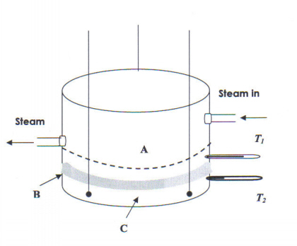

Fig.(2-1): simple form of Lees disc experiments.

a) The statical experiments :
Smear a little glycerine evenly on the two surfaces of the insulator to ensure a good thermal contact with the two metal faces with which they are to be in contact. Similarly dip the bulbs of the two thermometers T1 and T2 in glycerine to ensure good thermal contact. Assemble the apparatus and suspend it from the heavy stand and clamps. Pass steam in through the inlet tube and condense the steam issuing from the outlet by leading it beneath the surface of some cold water in a beaker . Protect the apparatus from receiving heat direct from the bunsen under the steam heater by using asbestos screens. Continue to pass steam until the lower thermometer T2 records a steady temperature θ2. Record also the temperature θ1 of the upper thermometer T1. The following parameters
Chapter two Experimental and theoretical details
are determined in this part:
diameter of lees disc = D.
mass of lower metal disc = m.
specific heat capacity of steel =C.
thickness of glass disc = d.
steady state temperature for the upper disc = θ1.
steady state temperature for the lower disc = θ2.

b) The dynamical experiment : remove the upper half A of the apparatus but leave the insulator (glass) resting on the lower steel disc. Using a low bunsen flame raise the temperature of the lower disc to about 10˚C above the steady temperature θ2 recorded in part(a). Allow it to cool to about 10˚C below θ2, record the temperature at minute intervals. Plot a cooling curve with values of temperature /K as coordinates against corresponding values of time /min. and take the slope from graph (dθ2 /dt) the relation used to calculate the thermal conductivity in this part of experiment is given as follows:

m C (dθ2 /dt ) = (1/4) π D${}^{2}$( (θ1 – θ2) / d) K${}_{e}$ …………..(2-1)

2-2-3: The specific heat capacity measurement :-

In this experiment we used a blackened copper calorimeter with copper lid to fit, bored with two holes to take a thermometer (0-100)˚C. The calorimeter should stand on insulating supports inside an outer jacket
which should be sufficiently large to ensure that the calorimeter is surrounded by air at a reasonably constant temperature. If possible the
outer jacket should be double - walled and should contain a mixture of
water and ice.
Chapter two Experimental and theoretical details
The procedure that was used in the determination of specific heat
Chapter two Experimental and theoretical details
capacity represented by taken into account the weigh of the calorimeter with the lid, heating up the bad insulator (glass) to above 90˚C and remove the calorimeter from the apparatus and put the heated glass, then replace the thermometer and lid and put the whole back into the cooling chamber. Record the temperature within the minute intervals down to 30˚C, re-weigh the calorimeter and its contents, including the lid, after rinsing thoroughly many times repeat the same procedure as mentioned above and determine the following parameters:

the mass of water = mw .

the mass of glass =mg .

and recorded the readings of time against temperature of water θw and of glass θg , then use the following relation to determine the heat capacity of glass:

m${}_{w}$ C${}_{w}$ ( dθ / dt )${}_{w}$ = m${}_{g}$ C${}_{g}$ ( dθ / dt )${}_{g}$ ………….(2-2)

where (dθ / dt) is the slopes taken from the graph between temperature of water and glass respectively with the time. The values of mass of water mw, mass of glass mg and heat capacity of water Cw are known.

2-3: Theoretical calculations:
From the I-V characteristic of NiTi samples prepared in previous study [44], we determine the heat capacity and thermal conductivity of NiTi thin film SMA of concentrations (Ni50Ti50) and (Ni49.7Ti50.3) at various temperatures by using the following relations :

Thermal conductivity :

Ke = Power / (length of specimentemperature) W/mk ……….(2-3)

Power = IV Watt …………(2-4)

Heat capacity:

C = Energy / (mass of thin film temperature) J /Kg.K …….…..(2-5)

Energy (J) = Energy (ev) / (6.24210${}^{\text{18}}$) …………(2-6)

Energy (ev) =V (ev / ev) = V (ev /1.610${}^{−\text{19}}$ v) = E(ev) ………….(2-7)

Then we determined the thermal conductivity in another method by using Lorentz equation [45]:

Ke = 3 (K${}_{B}$/ e)${}^{2}$ σ T (π${}^{2}$/ 3) ……..…..(2-8)
where:
KB = Boltzman constant =1.3 10${}^{−\text{23}}$ (J /K).
e = electron charge = 1.6 10${}^{−\text{19}}$ (C).
σ = electrical conductivity of thin film (Ω /m)${}^{−1}$ .
T = temperature (K).

The value of (σ T) was taken from previous experimental study [44], which is representing the area of the loop in the graph between σ (of thin film) against temperature.

Chapter two Experimental and theoretical details

Chapter

Three

Chapter Three
Results and Discussion

3-1 Introduction
This chapter includes the results and discussion of the following
calculations:
1) Thermal conductivity of the glass that was measured experimentally.
2) Heat capacity of the glass that measured experimentally.
3) Thermal calculations of NiTi thin films for two compositions Ni50Ti50
and Ni49.7Ti50.3.

3-2 Thermal conductivity measurements of glass substrate :
The simple set up of the experiment as well as known Lees disc experiment; consider a basic experiment to study the thermal conductivity for any insulator. The out put of this experiment represented by measuring the stability of temperature with time duration of the experiment. The aim of the experiment is to calculate the average value of thermal conductivity coefficient ke by using the following equation:

m C (dθ2 / dt) =( 1/4) π D${}^{2}$( (θ1 – θ2) / d) ke ………..(3-1)

where m, C, D and d are constant parameters as well define by the mass of lower metal disc m = 0.65 Kg, heat capacity of steel C = 500 J/ Kg.K, diameter of Lees disc D = 0.089 m and the thickness of glass disc d = 110${}^{−3}$m. θ1 and θ2 are the steady state temperature for both discs, upper and lower respectively, the difference between them are dependent constant. The plotting between both parameters, temperature and time tend to produce the thermal conductivity of glass through the slope of the
curve produced . The resultant out put of thermal conductivity
represented by fig.(3-1), which explain the variation of temperature with time by the following equation:

y = 47.003 exp (-x / 12.6755) + 979.813 exp (-x / 2266.4593) +
(-656.65) ……………(3-2)

Then we conclude the value of the slope which was (0.1625 K/sec.), then by application equation (3-1), we concluded the thermal conductivity of glass that was used as a substrate which is equal to K${}_{e}$= 0.8465 W/m.K, this value of thermal conductivity agrees with the standard value which is in the range (0.5-1.4) W/m.K for all types of glass. The reason for the decreasing temperature with respect to time, related to the reducing the phonon energy of the lattice vibration in the glass.

Figure (3-1). Variation of temperature with time of glass during cooling.

3-3 Heat capacity measurement of glass substrate :
The set up of simple experiment that was done in our laboratory is to measure the heat capacity of glass substrate. The aim of this experiment is to compare the result concluded with that calculated for thin film coated on the same type of glass. The out put of this experiment is translated by the following equation :
Chapter three Result and discussion

m${}_{w}$ C${}_{w}$ (dθ/dt)${}_{w}$ = m${}_{g}$ C${}_{g}$ (dθ/dt)${}_{g}$ ………….(3-3)

The parameters in this equation are defined as follows:
Mass of water m${}_{w}$= 5510${}^{−3}$Kg, heat capacity of water C${}_{w}$= 4181 J/Kg.K, mass of glass m${}_{g}$= 29 10${}^{−3}$Kg. The application of the above equation consider a good tools to identify the heat capacity of glass that was used in the film production. Figure (3-2) represents the relation of temperature with time for both water and glass which explain by equations (3-4) and (3-5) for water and glass respectively:

y = 30.659 exp (-x / 15.5397) + 30.6947 exp (-x / 26.967) +
307.4469 ……………..(3-4)

y = 1.6883 exp (-x / 0.6278) + 74.8227 exp (-x / 5.6362) +
292.7112 ……………..(3-5)
Then fitting curve tend to produce the thermal behavior equation for both water and glass. (dθ/dt)${}_{w}$= 2 K/sec. and (dθ/dt)${}_{g}$= 16 K/sec. The substituting of these slopes in the theoretical equation (3-3) one concluded the heat capacity of glass which was about (C${}_{g}$= 991.185 J/Kg..K), this result of heat capacity agrees with the standard value which is in the range (800-1000) J/Kg.K. One notice that figures (3-1) and (3-2) has the same behavior this is due to the fact that the two figures represented the behavior of temperature with time during cooling, since when removing the heat source the temperature decrease with time, therefore fitting equations also has the same form except the coefficient values.

Figure (3-2). Variation of temperature of water (upper curve) and glass
(lower curve) with time.

Chapter Three Results and discussion
3-4 Thermal calculation of thin films :
3-4-1 Thermal conductivity from I-V characteristics:
As we mentioned previously that our study is a complementary study for the experimental study that was done previously, the problem that was appeared in the previous experimental study was the breaking of the thin film slide which was discussed previously as a result of the phase transformation from Martensite to Austenite, then in order to overcome on this problem it is necessary to imply a thermal calculation on the thin film produced through the I-V characteristics that were measured previously. The purpose for that is to make a focusing on the breaking points as mentioned in figures (3-3) and (3-4) and tables (3-1) and (3-2) in order to calculate the energy evolved or absorbed by the samples under
Chapter Three Results and discussion
study at a certain substrate temperature (T${}_{s}$). The last two tables (3-3) and (3-4) represented the resultant scientific calculations for both tables (3-1) and (3-2) respectively, which give us more details on the thermal properties of a certain composition of thin films represented by heat capacity and thermal conductivity as a function of substrate temperature.

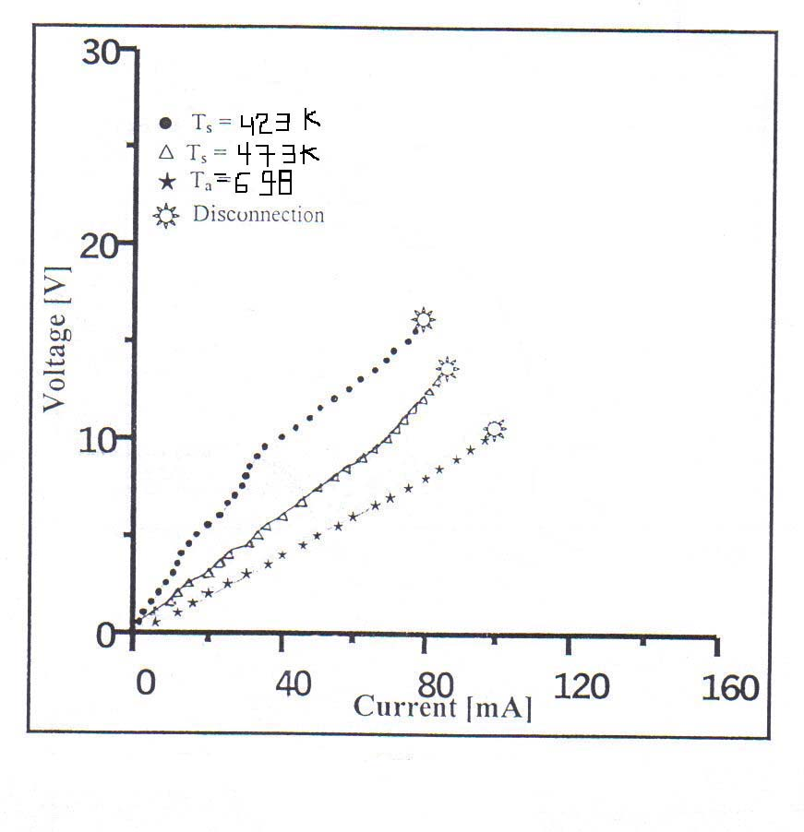
Figure (3-3): I-V characteristics of Ni${}_{\text{50}}$Ti${}_{\text{50}}$thin film at different
substrate temperatures [44].

Chapter Three Results and discussion

Chapter Three Results and discussion

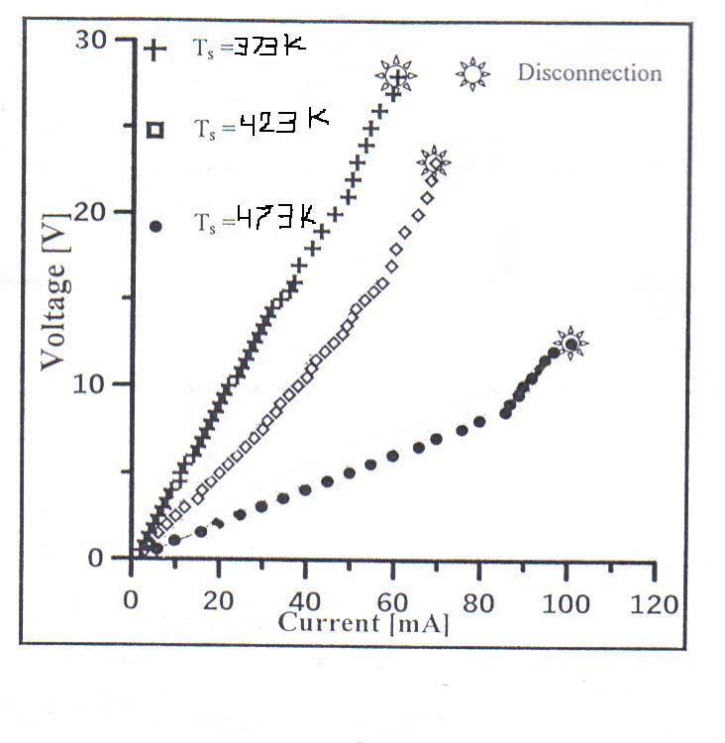
Figure (3-4): I-V characteristics of Ni${}_{\text{49}\text{.}7}$Ti${}_{\text{50}\text{.}3}$ thin film at different
substrate temperatures [44].

Table (3-1). Values of I, V and T${}_{s}$ for Ni${}_{\text{50}}$Ti${}_{\text{50}}$ thin film [44].
Chapter Three Results and discussion
T${}_{s}$ (K) | I (mA) | V(v)
423 | 80 | 16
473 | 81 | 14
698 | 101 | 11

Table (3-2). Values of I, V and T${}_{s}$ for Ni${}_{\text{49}\text{.}7}$Ti${}_{\text{50}\text{.}3}$ thin film. [44]
T${}_{s}$ (K) | I (mA) | V(v)
373 | 142 | 21
423 | 80 | 16
473 | 81 | 14

Table (3-3). Results of Ni${}_{\text{50}}$Ti${}_{\text{50}}$ thin film SMA
T${}_{s}$ (K) | E(J) | P(W) | C(J/Kg.K) | Ke(W/m.K)
423 | 16.021 | 1.28 | 10500 | 0.055
473 | 14.018 | 1.134 | 8300 | 0.0436
698 | 11.014 | 1.111 | 4400 | 0.0289

Table (3-4). Results of Ni${}_{\text{49}\text{.}7}$Ti${}_{\text{50}\text{.}3}$ thin film SMA
Chapter Three Results and discussion
T${}_{s}$ (K) | E(J) | P(W) | C(J/Kg.K) | Ke(W/m.K)
373 | 21.027 | 2.982 | 15700 | 0.145
423 | 16.021 | 1.28 | 10500 | 0.055
473 | 14.018 | 1.134 | 8300 | 0.044

One could note from tables (3-1) and (3-2) and the figures of (I-V) characteristic (3-3) and (3-4) that as the (T${}_{s}$) increase the (I-V) values at which the breaking takes place become lower, thus one could conclude a relation between the structure of the films and the crystallization temperature or in other words the indirectly with (I-V) values. At higher substrate temperature and low voltage the breaking of the samples occurs after a short period of measurement. But at low substrate temperature and higher voltage, the breaking of samples takes place at longer period measurement.
It was clear for both Ni${}_{\text{50}}$Ti${}_{\text{50}}$ and Ni${}_{\text{49}\text{.}7}$Ti${}_{\text{50}\text{.}3}$ thin films that there is a decreasing in the heat capacity and thermal conductivity as mentioned
Chapter three Result and discussion
in tables(3-3) and (3-4). The previous study showed the investigation of the crystallization of the like NiTi alloy with the increasing of substrate temperatures, which will help us in the attribution of the behavior in the above figures. It was clear that the ability of the amorphous phase to imply a diffusing of the phonon energy through the lattice vibration is more simpler than that of the pure crystalline due to the presence of long range and short range order within the structure of polycrystalline thin film, that imply to spend a part of phonon energy with the grain and grain boundaries. For this reason the decreasing in the heat capacity and thermal conductivity is valid with increasing the crystallization in the NiTi thin film.

3-4-2 Thermal conductivity by the hysterises loop:
Chapter three Result and discussion
These calculations were done from the application of Lorentz equation on the hysterises loop of electrical conductivity as a function of temperature for both heating and cooling cycles with two different composition as shown in figures (3-5) up to (3-10). The purpose from this method that was taken into account the area of hysterises loop between the heating and cooling cycles and then transfer this area in terms of thermal conductivity depends on the Lorentz equation as follows:

K${}_{e}$ = (π k${}_{B}$/ e)${}^{2}$ σ T ……………..(3-6)
Chapter three Result and discussion
where the parameter (σ T) explain the area of the hysteresis loop in the conductivity of the film having a reversible process between Martensite and Austenite phases. As it was well known, NiTi SMA thin films presented shape memory effect due to thermoelastic Martensitic transformation. This thermoelastic Martensitic transformation may be induced either by stress or by effect of temperature. The calculations of (σ T) and thermal conductivity by this method listed in tables (3-5) for Ni${}_{\text{50}}$Ti${}_{\text{50}}$ and (3-6) for Ni${}_{\text{49}\text{.}7}$Ti${}_{\text{50}\text{.}3}$ respectively. The values of (σ T) taken from figures (3-5), (3-6) and (3-7) for Ni${}_{\text{50}}$Ti${}_{\text{50}}$ and figures (3-8), (3-9) ,(3-10) for Ni${}_{\text{49}\text{.}7}$Ti${}_{\text{50}\text{.}3}$ respectively.

Table (3-5). Calculations for Ni${}_{\text{50}}$Ti${}_{\text{50}}$thin film SMA.
Ts (K) | σ T(Ohm.m)${}^{−1}$K10${}^{2}$ | Ke (W/mK)
423 | 8054 | 0.059
473 | 6707.9 | 0.049
698 | 326 | 0.01

Table (3-6). Calculations for Ni${}_{\text{49}\text{.}7}$Ti${}_{\text{50}\text{.}3}$thin film SMA.
Ts (K) | σ T(Ohm.m)${}^{−1}$K10${}^{6}$ | Ke (W/mK)
373 | 1.332 | 0.097
423 | 32.135 | 2.357
473 | 157.39 | 11.545

Chapter three Result and discussion
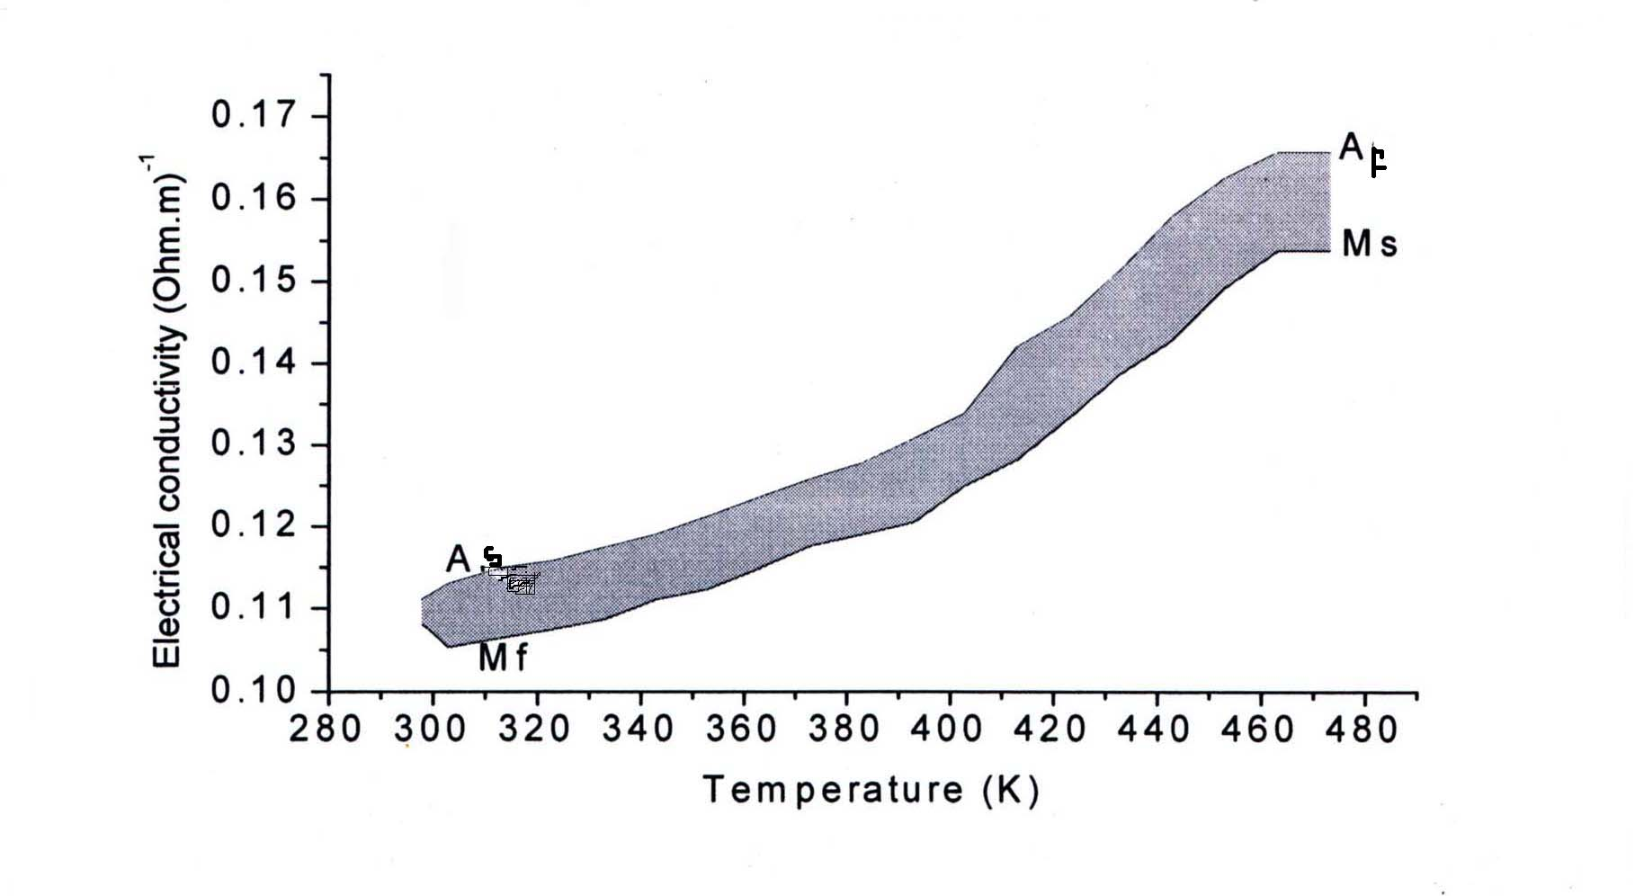

Figure (3-5). Influence of electrical conductivity measurement as a function of
temperature for Ni${}_{\text{50}}$Ti${}_{\text{50}}$at substrate temperature Ts = 423 K [44].

Figure (3-6). Influence of electrical conductivity measurement as a function of
temperature for Ni${}_{\text{50}}$Ti${}_{\text{50}}$at substrate temperature Ts = 473 K [44].

Chapter three Result and discussion

Chapter three Result and discussion
Figure (3-7). Influence of electrical conductivity measurement as a function of
temperature for Ni${}_{\text{50}}$Ti${}_{\text{50}}$at substrate temperature Ts = 698 K [44].

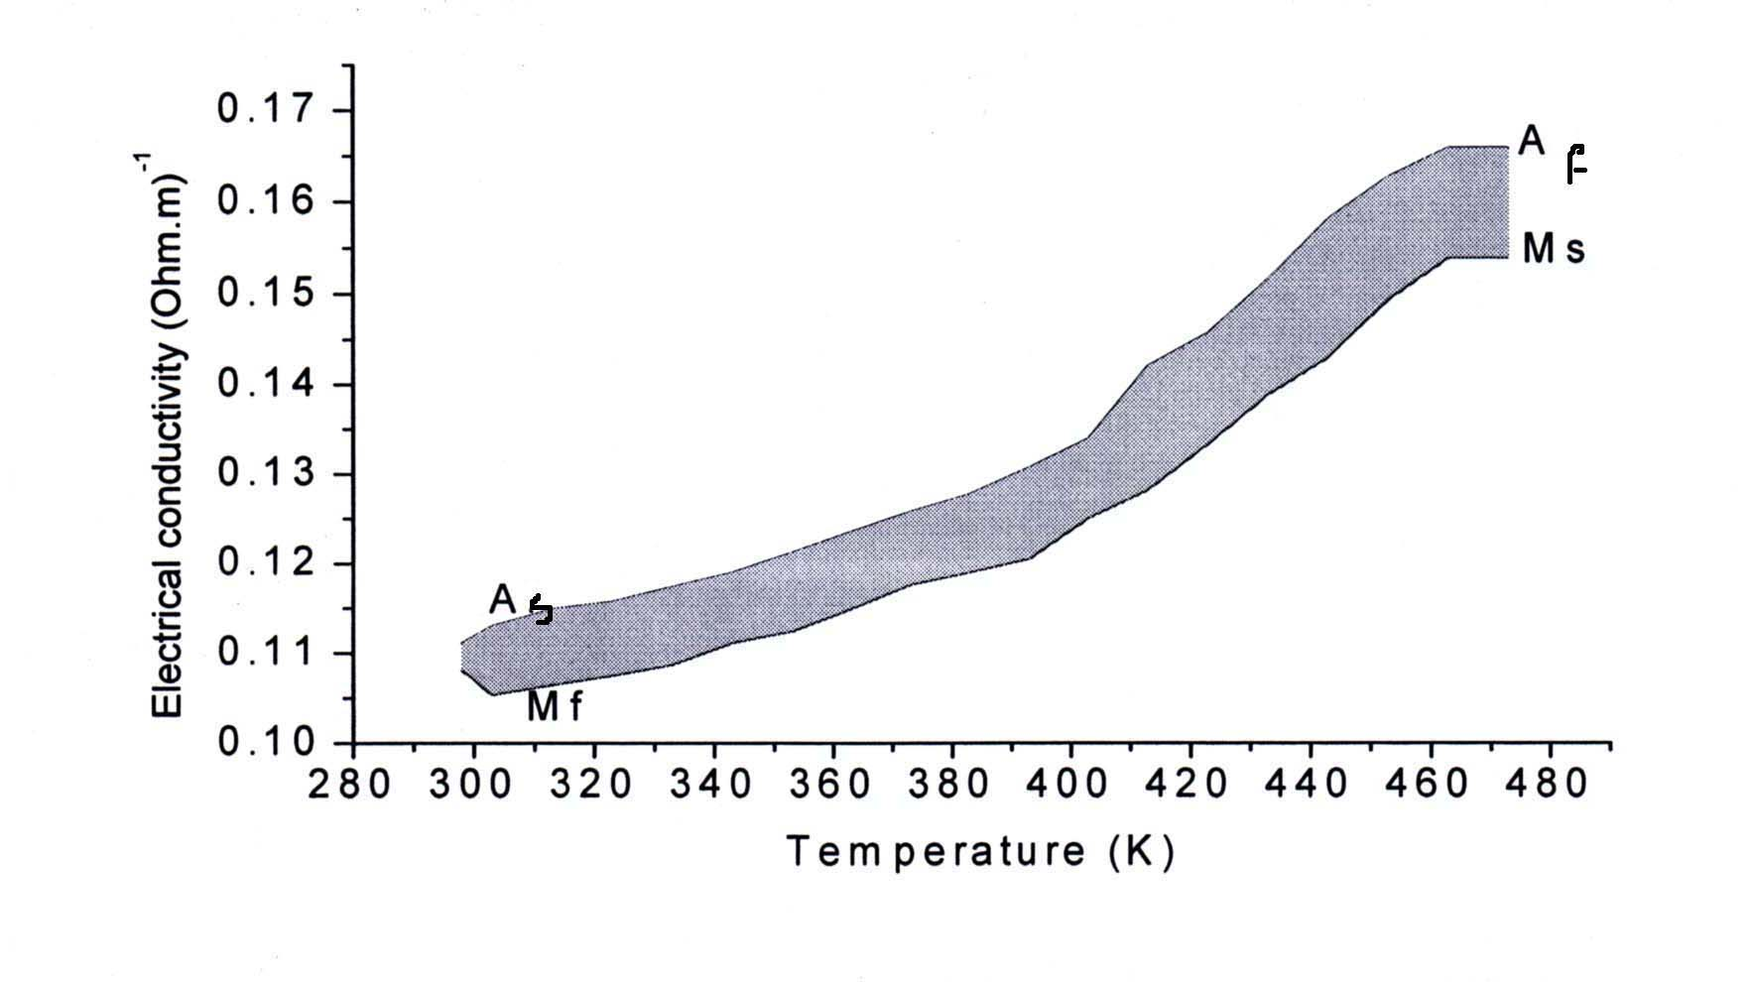

Figure (3-8). Influence of electrical conductivity measurement as a function of
temperature for Ni${}_{\text{49}\text{.}7}$Ti${}_{\text{50}\text{.}3}$at substrate temperature Ts = 373 K [44].

Chapter three Result and discussion
Figure (3-9). Influence of electrical conductivity measurement as a function of
temperature for Ni${}_{\text{49}\text{.}7}$Ti${}_{\text{50}\text{.}3}$at substrate temperature Ts = 423 K [44].

Chapter three Result and discussion

Figure (3-10). Influence of electrical conductivity measurement as a function of
temperature for Ni${}_{\text{49}\text{.}7}$Ti${}_{\text{50}\text{.}3}$at substrate temperature Ts = 473 K [44].

Table (3-5) and (3-6) for the compositions Ni${}_{\text{50}}$Ti${}_{\text{50}}$ and Ni${}_{\text{49}\text{.}7}$Ti${}_{\text{50}\text{.}3}$ respectively showed that when the substrate temperature increase, the value of (σ T) which represent the area of the hysteresis loop decrease and then decreasing the thermal conductivity of thin film Ni${}_{\text{50}}$, while for Ni${}_{\text{49}\text{.}7}$Ti${}_{\text{50}\text{.}3}$ when the substrate temperature increase the value of (σ T) increase and hence increasing the thermal conductivity of thin film, the behavior of this film denoted to the change in the structure of the two films. Also this behavior agrees with the theoretical application of Lorentz equation, since from this equation one noticed that the thermal conductivity is proportional to (σ T).
The above results of glass substrate and thin films appeared that the thermal properties represented by heat capacity and thermal conductivity of thin films which are greater than that of glass substrate.
Chapter three Result and discussion
In general the breaking in the thin film slide occur in glass substrate due to the high amount of heating energy resulting from the phase transformation process between Austenite and Martensite which exerts on the thin film slide, since the heat capacity of glass is lower than that of thin films, hence it is can not bear this heating energy. Our results
Chapter three Result and discussion
differ from that in reference [44] which states that the breaking occur in glass due to the losing of heat from glass.

Chapter

Four

Chapter Four
Conclusion and Future Work

4-1 Conclusion and Future Work :
we try to understand what is the reason for breaking of the thin film slide NiTi -SMA that was appeared in previous study. The thermal measurements and calculations of the sample under study for both glass and thin films give us a more prediction on the behavior of thin film with respect to glass as a function of the phase transformation for the thin films Ni${}_{\text{50}}$Ti${}_{\text{50}}$ and Ni${}_{\text{49}\text{.}7}$Ti${}_{\text{50}\text{.}3}$.
It was clear that the phase transformation has a negative effect on the glass slide because the thermal quantity of thin film represented by heat capacity and thermal conductivity were greater than that of the glass slide. This inequality in the thermal quantity between thin film and glass substrate tend to produce a huge quantity of thermal energy in the sandwich region (the meeting region between glass and thin film) that play very important parameter in the breaking of the slide.
Chapter Four Conclusion and Future Work
To avoid the problem that occurs in the thin film slide, which represented by the breaking of the slide and depending on the obtainable results from our study the following statements must be followed whch also can be considered a recommended for future works:
- The crystalline metal should be use as a substrate, is favor than the
amorphous glass because the breaking in the crystalline phase is harder than that in the amorphous phase.
- Thermal parameters of any substrate that should be applied whether it is crystalline or amorphous must be higher than or at least equal to thermal parameters of NiTi thin film, such as steel, aluminum and diamond in order to avoid the breaking occur in substrate. In this case these substrates are able to contains the thermal energy evolved
Chapter Four Conclusion and Future Work
from the NiTi shape memory thin film through the phase
transformation from Austenite to Martensite.

References
1) Z. Abdulameer; "Theoretical investigation in the shape memory alloy
(SMA) austenite –martensite transformation", Ph.D. thesis,
Department of Physics , Baghdad University , Iraq (1995).

2) S. M. T. Hashemi and S.E.Khadem; Int. J. of Mech. Sci., vol.48, pp.
44- 52, (2006) .

3) X. M. Wang and Z. F. Yue; Mater. Sci. and Eng., vol. A 425, pp. 83-
93, (2006).

4) R.S. Elliott, J.A. Shaw, N.Triantafyllidis; J. for Mech. Phys. of Solids,
vol.50 (11), pp.2463-2493, (2002)b.

5) K. Bhattacharya; "Microstructure of martensite:why it forms and how
it gives rise to the shape- memory effect", Oxford Series on Materials
Modeling, first ed. Oxford University Press, Oxford (2003).

6) M.Pitteri; J. of Elasticity vol.14, pp.175-190, (1984).

7) P.Toledano and V.Dmitriev; World Scientific, Singapore, 1996.

8) J. Cui, Y. S. Chu , O. O. Famodu , Y. Furuya , G. H. Simpers, R.D. James , A. Ludwig , S. Thienhaus, M. Wuttig, Z. Zhng and I. Takeuchi; Nature materials, vol.5, PP.286-290, (2006). www.nature.com/naturematerials

9) J. N. Albino Soto, N. Correa and J. F. Irizarry. Applications of
Engineering Mechanics in Medicine, GED University of Puerto Rico,
(2005). http://www.ece.uprm.edu/~mgoyal/home.htm

10) S. Cabrera , N. Harrison , D. Lunking , R. Tang , T. Valentine and C.
Ziegler; "Shape memory alloy latching microactuator", (2002).

11) T. Biggs, M. B. Cortie, M. J. Witcomb and L. A. Cornish, Platinum
Metals,vol.47,no.4,pp.142-156, (2003).
http://www.platinum.matthey.com

12) H.D. Gu, L. You, K.M. Leung, C.Y. Chung, K.S. Chan, J.K.L Lai;
Applied Surface Science, pp.127-129, 579-583, (1998).

13) M.H. Ren, L. Wang, D. XU, and B.C.Cai; Mater. Sci. and Design,
vol.21, no.6, pp.583-586, (2000).

14) H.Funakubo ditor "Shape Memory Alloys", New York: Gordon
Breach Sci. Pub; 1987.

15) S. P. Mizar "Thermomechanical characterization of Nitinol and
Nitinol based structure using ACES methodology"; Ph. D thesis,
Worcester Polytechnic Institute, (2005).

16) C.Y.Li, C.M.Wayman . editor "PhaseTransformation and Related
Phenomena in Steels" American Society for Metals, vol.3, 1973.

17) D.A.Porter and K.E.Easterling "Phase Transformation in Metals and Alloys". Chapman and Hall Sec. edition, 1992.

18) C. M. Wayman "Introduction to Crystallography of Martensitic
Transformation"; New York: Macmillan, 1964.

19) J.W.Christian "The Theory of Transformation in Metals and Alloys";
Pergamon Press, Oxford, 1965.

20) D. E. Hodgson, M. H. Wu and R. J. Biermann; "Shape Memory
Applications", Inc., (1999), web sit:
http://www.smainc.com/email:info@sma-inc.com

21) B. Gabry, C. Lexcellent, V.H. No, and S. Miyazaki; Thin Solid Films,
vol.372, no.(1-2), pp.118-133, (2000).

22) http://www.sma-inc.com/NiTi properties.html

23) www.Schott.com/advanced-optics.

24) http://en.wikipedia.org/wiki/Crystal structure.

25)http://www.engr.sjsu.sdu/cme/cmecourses/MatE25/Lab/Lab%202%20
crystal%20structure.

26) http://www.ee./ut.fi/static/fi/lab/elemat.

27) Otsuka and C.M.Wayman; "Shape memory materials", Chambridge
University press, pp.149-163, (1998).

28) H. Funkubo; "Shape memory alloys", New York, Gordon Breach
Sci. Pub., (1987).

29) A.L. Mckelvey and R.O.Ritchie; to be published in philosophical
magazine A, (1999).

30) Seelecke and Kastner; "Afully coupled thermomechanical model for
shape memory alloys", Berlin, (2002).

31) S.Somiya "Advanced Technical Ceramics"; Academic Press, Japan,
1984.

32) http://www.meca.polymtl.ca/trochu/meca.

33) M.T. Dove; "Introduction to lattice dynamics", Cambridge University
Press (1993).

34) Y. Shao, P.C.Clapp, J.A. Rifkin, Metal. Transact,vol. 27A, no.6,
pp.1477-1489, (1996).

35) M.Kaack , I.Delgadillo-Holtfort , T.Yohannes and J.Petzl; Mater.
Sci. and Eng, vol. A 378, PP.119-121, (2004).
http://www.elsevier.com/locate/msea

36) S. Nemat – Nasser and w. Guo Guo; Mech. of Mater, Vol.38, pp.
463-474, (2006). http://www.elsevier.com/locate/mechmat

37) W. M. Huang; Mater. Sci. and Eng, vol.A 392, pp. 121-129, (2005).
http://www.elsevier.com/locate/msea

38) J.F.Wan , X.L.Lei , S.P.Chen and T.Y.Hsu; Scripta Materialia,
vol.52, pp. 123-127, (2005). http://www.actamat-journals.com

39) J.Khalil-Allafi , G.Eggeler , A.Douhy , W.W.Schmahl and
Ch.Somsen; Mater. Sci. and Eng., vol. A 378, pp.148-151, (2004).
http://www.elsevier.com/locate/msea

40) E.Schüller ,M.Bram , H.P.Buchkremer and D.Stöver; Mater. Sci.
and Eng., vol.A 378, pp.165-169, (2004).
http://www.elsevier.com/locate/msea

41) J.Gibkes , W.Siegert , D.Pietzel , I.Delgadillo-Holtfort , B.K.Bein and
J.Pelzl.; Mater. Sci. and Eng., vol.A 378, pp.175-179, (2004).
http://www.elsevier.com/locate/msea

42) K. Weinert and V. Petzoldt; Mater. Sci. and Eng., vol.A 378, pp.180-
184, (2004). http://www.elsevier.com/locate/msea

43) B. Kuai Lai , H.Kahn , S.M.Phillips , Z.Akase and A.H.Heuer;
Mater. Res. Society, vol.19 , No.10 (2004).

44) K. A. Al-Majidi; "Phase transformation of TiNi shape memory alloy
thin films", Msc. Sci. Department of Physics, College of Science,
Saddam University, Iraq, (2000).
45) C. Kittel; "Introduction to solid state physics". 6th ed. Published by
John Wiley and Sons, Canada

الخـلاصـه
سبائك ذاكرة الشكل (SMA) shape memory alloyاو ما يسمى بالمواد الذكيه هي نوع من السبائك المعدنيه التي تعاني تحولات طور من الاوستنايت الى المارتنسايت عند تعرضها الى حراره او اجهاد كافي للتحول ولها القدره على الرجوع الى نفس حالة الشبيكه قبل التحول عند زوال المؤثر .
لقد تم التركيز في هذه الدراسه على الخواص الحراريه كمحاوله لفهم التصرف الذي يحدث في الغشاء الرقيق والذي يتمثل بكسر شريحة الفلم عند تسليط قيمه معينه من الفولطيه والتيار وعند قيمه معينه من حرارة الاساس . وقد اخترنا دراسة غشاء NiTi لان له دور مهم في التطبيقات الطبيه والصناعيه .
لقد تم حساب التوصيل الحراري والسعه الحراريه لغشاء NiTi نظـريا وكذلك تم حساب التوصيل الحراري والسعه الحراريه للزجاج المستخدم كاساس للغشاء عمليا وبعدها تمت مقارنة نتاءج هذه الحسابات للغشاء والزجاج وتفسير سبب الكسر في شريحة الغشاء والذي تبين انه يحدث في الزجاج نتيجة للفرق الكبير في الخواص الحراريه بين الغشاء والزجاج وهذا بسبب عدم تحمل الزجاج للطاقه الحراريه العاليه الناتجه خلال عملية تحول الطور بين الاوستنايت والمارتنسايت في الغشاء الرقيق والتي تسلط على الشريحة الزجاجيه للغشاء.

جمهورية العراق
وزارة التعليم العالي والبحث العلمي
جامعة النهرين
كلية العلوم

دراسة الخواص الحراريه للاغشيه الرقيقه الذكيه نوع نيكل- تيتانيوم

رساله
مقدمه الى كلية العلوم في جامعة النهرين
كجزء من متطلبات نيل درجة الماجستير
في الفيزياء

من قبل
هديل ثامر خضير
بكلوريوس ٢٠٠٣

المشرف
د. عماد خضير الشكرچي

اذار ٢٠٠٨ ربيع الاول ١٤٢٨

